Section I: Scenario Demographics

Scenario Title: | 30% BSA Burn with CO/CN Poisoning
Date of Development: | 16/05/2015 (DD/MM/YYYY)
Target Learning Group: | Juniors (PGY 1 – 2) Seniors (PGY ≥ 3) All Groups

Section II: Scenario Developers

Scenario Developer(s): | Kyla Caners
Affiliations/Institution(s): | McMaster University
Contact E-mail (optional): | kcaners@gmail.com

Section III: Curriculum Integration

Learning Goals & Objectives
Educational Goal: | To expose learners to the complex management and differential considerations in a critically ill patient from a house fire.
CRM Objectives: | Effectively lead team members through complex critical scenario.
Medical Objectives: | - Recognize the need to intubate patient with significant burns.  - Adequately fluid resuscitate patient with significant burns.  - Recognize possible CO and CN exposure and administer treatment.

Case Summary: Brief Summary of Case Progression and Major Events
A 33 year-old female is dragged out of a burning house and presents to the ED unresponsive. She has soot on her face, singed eyebrows, and burns to her entire chest, the front of her right arm, and part of her right leg. She is hypotensive and tachycardic with a GCS of 3. The team should proceed to intubate and fluid resuscitate. After this, the team will receive a critical VBG result that reveals profound metabolic acidosis, carboxyhemoglobin of 25 and a lactate of 11. If the potential for cyanide toxicity is recognized and treated, the case will end. If it is not, the patient will proceed to VT arrest.

Facilitators Required to Run Session
Instructors (faculty or senior resident): 1-2 (one to observe, one to play family member). Could easily have observing faculty member come in to play family member at end of case if short on instructors.
Confederate nurse: 1 (to assist at bedside, cue as to patient appearance)
Sim tech: 1

Section IV: Scenario Script

A. Scenario Cast & Realism
Patient: | Computerized Mannequin |  |  |  |  | Realism:  Select most important dimension(s) |  |  | Conceptual
 | Mannequin |  |  |  |  |  |  |  | Physical
 | Standardized Patient |  |  |  |  |  |  |  | Emotional/Experiential
 | Hybrid |  |  |  |  |  |  |  | Other:
 | Task Trainer |  |  |  |  |  |  |  | N/A
Confederates | Brief Description of Role
Family member | Arrives part way through scenario very distraught about fire. When questioned, will eventually give history that the patient has recently been depressed. Has previously tried hanging herself.
B. Required Monitors
EKG Leads/Wires |  |  | Temperature Probe |  |  |  | Central Venous Line
NIBP Cuff |  |  | Defibrillator Pads |  |  |  | Capnography
Pulse Oximeter |  |  | Arterial Line |  |  |  | Other:
C. Required Equipment
Gloves |  |  | Nasal Prongs |  |  |  | Scalpel
Stethoscope |  |  | Venturi Mask |  |  |  | Tube Thoracostomy Kit
Defibrillator |  |  | Non-Rebreather Mask on patient at start of case |  |  |  | Cricothyroidotomy Kit
IV Bags/Lines |  |  | Bag Valve Mask |  |  |  | Thoracotomy Kit
IV Push Medications |  |  | Laryngoscope |  |  |  | Central Line Kit
PO Tabs |  |  | Video Assisted Laryngoscope |  |  |  | Arterial Line Kit
Blood Products |  |  | ET Tubes |  |  |  | Other:
Intraosseous Set-up |  |  | LMA |  |  |  | Other:
D. Moulage
Soot on face, singed eyebrows. Fake burns to chest, right arm/abdomen/leg. (Nothing circumferential) Cutting scars across left forearm. Non-rebreather on patient at start of case.

E. Approximate Timing
Set-Up: |  | 10 min |  | Scenario: | 12 min |  |  | Debriefing: |  | 10 min

Section V: Patient Data and Baseline State

A. Clinical Vignette: To Read Aloud at Beginning of Case
A 33-year-old female has just been brought into your tertiary care ED. She was dragged out of a house fire and is unresponsive. The etiology of the fire is unclear, but the home was severely damaged. The EMS crew that transported her noted significant burns across her chest, abdomen, arm, and leg.
B. Patient Profile and History
Patient Name: Sheena Sherman |  |  |  |  |  | Age: 33 |  |  |  |  |  | Weight: 70
Gender: M F |  |  |  |  |  | Code Status: Full
Chief Complaint: burns, aLOC
History of Presenting Illness: Dragged out of a house fire unresponsive. No other members of household at the scene. Unclear etiology of fire.
Past Medical History: |  | Unknown |  |  |  |  | Medications: |  |  | Unknown
Allergies: None known.
Social History: Unkown
Family History: Unknown.
Review of Systems: |  | CNS: |  |  | Unable
 |  | HEENT: |  |  | Unable
 |  | CVS: |  |  | Unable
 |  | RESP: |  |  | Unable
 |  | GI: |  |  | Unable
 |  | GU: |  |  | Unable
 |  | MSK: |  |  | Unable |  |  |  |  |  | INT: |  | Unable
C. Baseline Simulator State and Physical Exam
No Monitor Display |  |  |  | Monitor On, no data displayed |  |  |  |  | Monitor on Standard Display
HR: 130/min |  |  | BP: 75/45 |  |  |  | RR: 18/min |  |  |  |  |  | O₂SAT: 96%
Rhythm: sinus tach |  |  | T: 36.1ºC |  |  |  | Glucose: 6.1 mmol/L |  |  |  |  |  | GCS: 3 (E 1 V 1 M1)
General Status: Unresponsive.
CNS: | GCS 3. Pupils 3mm bilat, minimally reactive.
HEENT: | No signs HI. Soot on face. Singed eyebrows.
CVS: | Nil.
RESP: | GAEB. No adventitious.
ABDO: | Abdo soft, NT.
GU: | Nil.
MSK: | No signs trauma. |  |  |  |  |  | SKIN: | Burns to entire chest, R arm, abdomen, and R leg. Cutting scars to L arm.

Scenario States, Modifiers and Triggers
Patient State | Patient Status | Learner Actions, Modifiers & Triggers to Move to Next State
1. Baseline State  Rhythm: Sinus tach  HR: 130/min  BP: 75/45  RR: 18/min  O₂SAT: 96 %  T: 36.1ºC | Unresponsive with GCS 3. | Learner Actions  - 2 large bore IVs, bolus 2L  - 100% O2, monitors  - Labs: VBG, carboxyHb, lactate, coags, trop, lytes, Cr  - Check glucose: 6.3  - Td administration  - Full exposure, determine burn area (22.5% TBSA) | Modifiers  Changes to patient condition based on learner action  - 2L IVF HR 120, BP 82/50  - If no discussion of intubation by 5 min, RN to prompt  Triggers  For progression to next state  - Intubate 2. Intubation  - 7 minutes 3. Critical VBG
2. Intubation  HR 120  BP 80/50 | Unchanged. | Learner Actions  - Push dose pressors at bedside  - Use BP neutral agent (ketamine or etomidate)  - Double set-up (possible difficult airway)  - Intubate  - CXR to confirm placement | Modifiers  - Propofol used BP 60/30  - Any other agent used BP 70/45  Triggers  - 7 minutes 3. Critical VBG
3. Critical VBG  HR 115  BP 75/45 |  | Learner Actions  - Ensure patient on 100% O2  - Continue IVF bolus  - Start vasopressor infusion  - Give hydroxycobalamin 5mg iv over 15 min  - ± Call Poison Control (they advise hydroxycobalamin)  - ± Na thiosulfate 12.5g iv | Modifiers  - Vasopressor started BP 85/55  Triggers  - 10 min 4. Arrest  - Hydroxycobalamin given 5. Resolution
4. Arrest  Rhythm PEA  BP -/- | Patient pulseless. | Learner Actions  - Ensure quality CPR  - Intubate if not yet done  - Epinephrine q3min  - HCO3 ampules  - Give hydroxycobalamin | Modifiers  Triggers  - Hydroxycobalamin given 5. Resolution  - 12 minutes 5. Resolution
5. Resolution  Rhythm sinus tach  HR 110  BP 95/60 | Patient remains unresponsive.  Family member arrives. | Learner Actions  - Call ICU/Plastics  - Call Poison Centre  - Call for hyperbarics  - Disclose bad news to family | ICU arrives to manage patient  END CASE
Section VI: Scenario Progression

Section VII: Supporting Documents, Laboratory Results, & Multimedia

Laboratory Results
VBG | pH: 6.98 | PCO₂: 28 | PO₂: 70 | HCO₃: 6 | Lactate: 11
Carboxyhgb: 0.4

Images (ECGs, CXRs, etc.)
Sinus tachycardia ECG  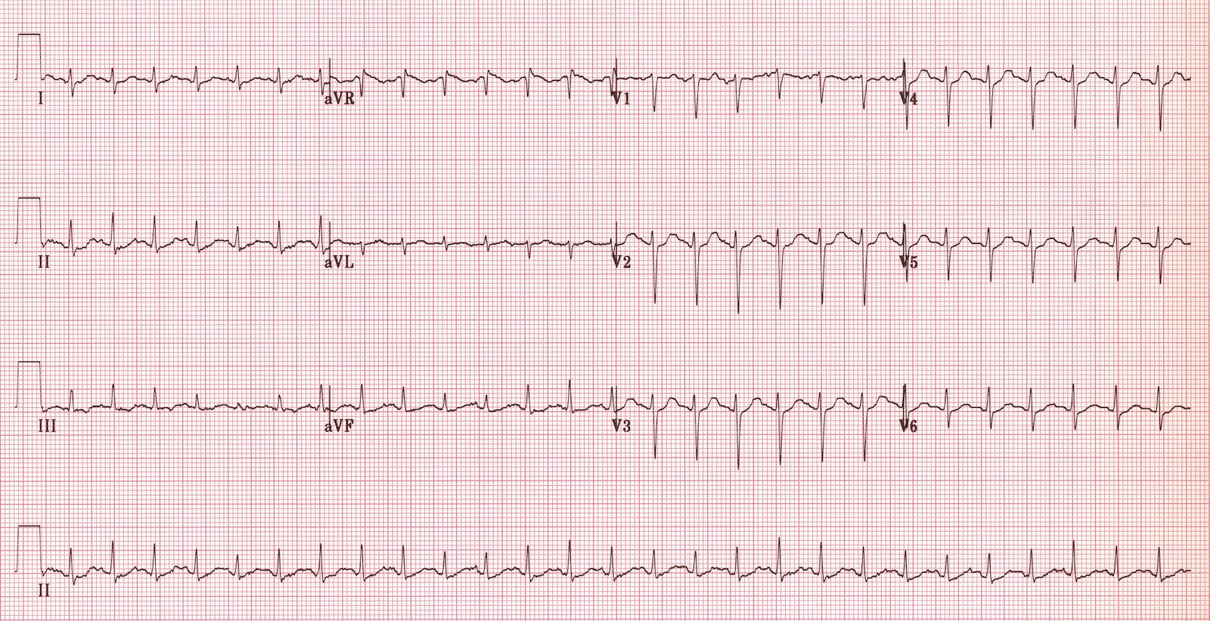  ECG source: https://lifeinthefastlane.com/ecg-library/sinus-tachycardia/ | Normal post-intubation CXR  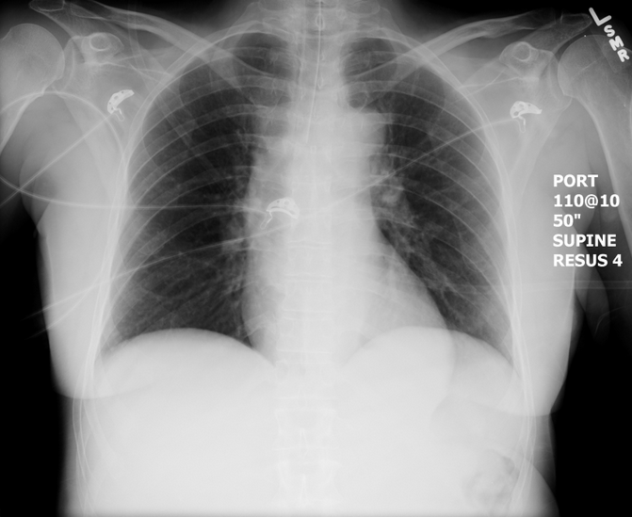  CXR source: https://emcow.files.wordpress.com/2012/11/  normal-intubation2.jpg

Section VIII: Debriefing Guide

General Debriefing Plan
Individual | Group |  | With Video | Without Video
Objectives
Educational Goal: |  | To expose learners to the complex management and differential considerations in a critically ill house fire patient.
CRM Objectives: |  | Effectively lead team members through complex critical scenario.
Medical Objectives: |  | - Recognize the need to intubate patient with significant burns.  - Adequately fluid resuscitate patient with significant burns.  - Recognize possible CO and CN exposure and administer treatment.
Sample Questions for Debriefing
- What were the clues to CN toxicity in this patient?
- What are the recommended treatments for CN toxicity?
- What is the Parkland formula? How would it be applied in this case? (Hint: it’s not)
- What is the management of CO toxicity? What are the criteria for hyperbarics?
- What was challenging about this case?
- How do you feel your team did in working through uncertainty around the diagnosis? Did the leader facilitate input from others?
Key Moments
Recognition of need to intubate
Realization that shock is not responding to fluids
Recognition of CO and CN poisoning

